Jim Lindsay
Born and bred in the Kingdom of Fife, Jim started to play the accordion at the age of 6. While still a teenager, he was Scottish Accordion Champion in the early 1970s. Jim formed his band in the 1980s and since then has consistently been one of the most respected and in-demand musicians on the Scottish music scene. His music is often featured on BBC Radio and he has produced several CDs. He has played across Europe, North America, New Zealand, Australia, Japan and China and is no stranger to Blairgowrie Town Hall. Having played for our very first October event in 2018, and some others in between, along with many Ericht Scottish Country Dances, we say a huge ‘thank you’ to Jim as he plays for one final time for us at this event and wish him well.

Further information from:-
www.blairgowrietownhall.co.uk
Email: enquiries@blairgowrietownhall.co.uk
Telephone: 07938 039479
www.erichtdance.co.uk
https://discoverblairgowrie.co.uk

Janet Johnston
Janet started Scottish Country and Highland Dancing as a child and manages to arrange her work in Edinburgh around her Scottish Country Dancing. She continues to teach both at home and abroad and will have completed her second year as Director of the RSCDS Summer School in August. Janet is delighted to return to Blairgowrie this October.

Saturday 24th October 2026

2:00pm - 4:00pm
(Doors Open at 1.30pm)
Dance Class
with Janet Johnston and Jim Lindsay

7:30pm-11:00pm
Scottish Country Dance
with The Jim Lindsay Band

************

Registered SCIO
SC028287

Blairgowrie Town Hall Association
in conjunction with
Ericht Scottish Country Dance Club
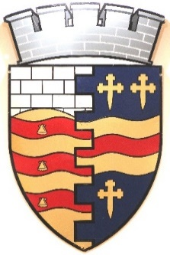
presents

BLAIRGOWRIE
HALF -DAY SCHOOL & DANCE
24TH OCTOBER 2026
