Half Day School Dance, Saturday 24th October 2026, 7.30pm, Blairgowrie Town Hall, Jim Lindsay

TRIP TO BLAIRGOWRIE (Silver Wedding Jig) (J8x40) 3C (4C set) Evelyn Ramwell 3rd Kirkbrae Collection
1- 8 1s set, cross down RH to double triangle position with 2s+3s and set, 1s turn 1st corners RH into 2nd place opposite sides
9-16 1s dance reels of 3 on sides passing 2nd corners LSh and end crossing to 2nd place own sides
17-24 1s dance reels of 3 on own sides passing 3rd corner RSh
25-32 1s turn 3rd corners RH into lines of 3 across (1M between 2s facing down and 1L between 3s facing up) and all set, 1s pass RSh and cast round 4th corner to 2nd place
33-40 2s+1s+3s circle 6H round and back

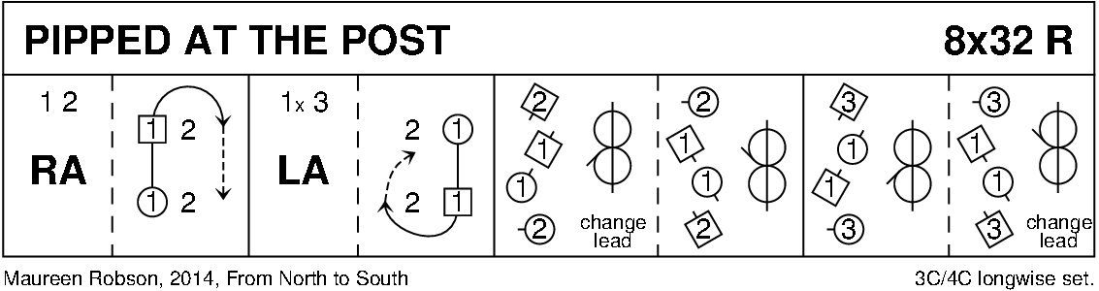

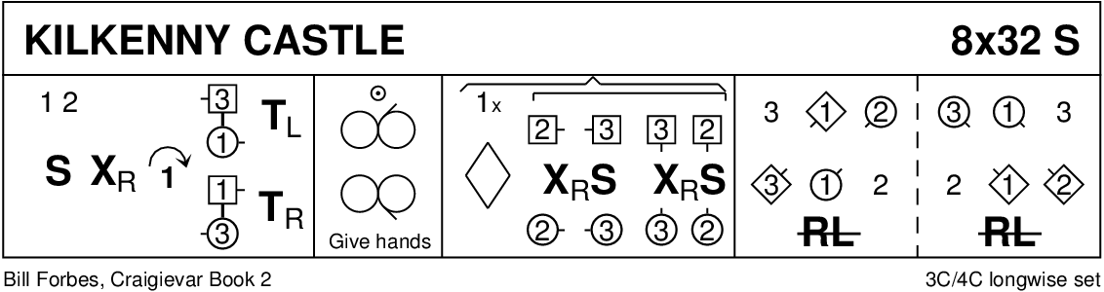

THE EDMONTON SNOWBALL 1 (J4x32) 4C set Enid Fouler Edmonton Workshop 1986
1- 8 1M+2L also 3M+4L advance and retire diagonally and dance DoSiDo diagonally
9-16 1L+2M also 3L+4M repeat
17-20 1s ½ turn RH, 1s+2s dance ½ RH across
21-24 1s ½ turn RH, 1s+3s dance ½ RH across while 2s turn RH once round (4 bars)
25-28 1s ½ turn RH, 1s+4s dance ½ RH across while 2s+3s dance RH across once round
29-32 1s set (4 bars) while 2s+3s+4s set and cross RH. 2341

TEACHER’S CHOICE

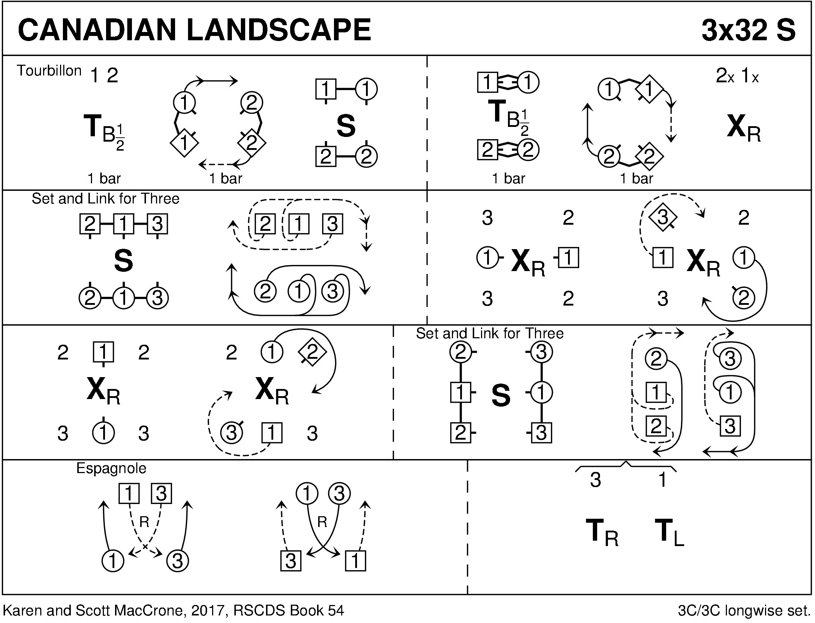

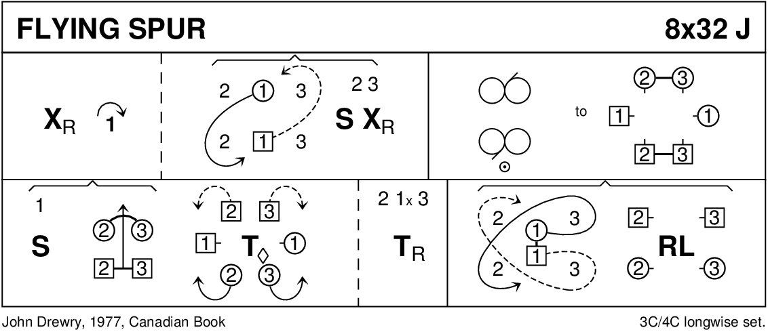

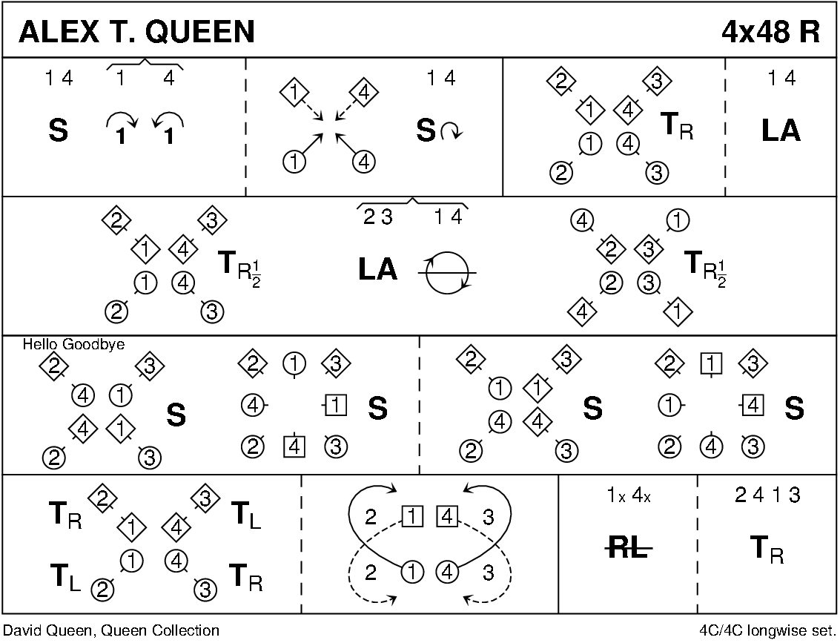

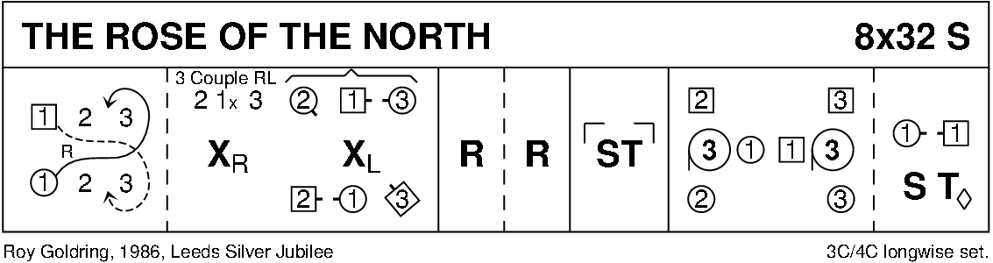

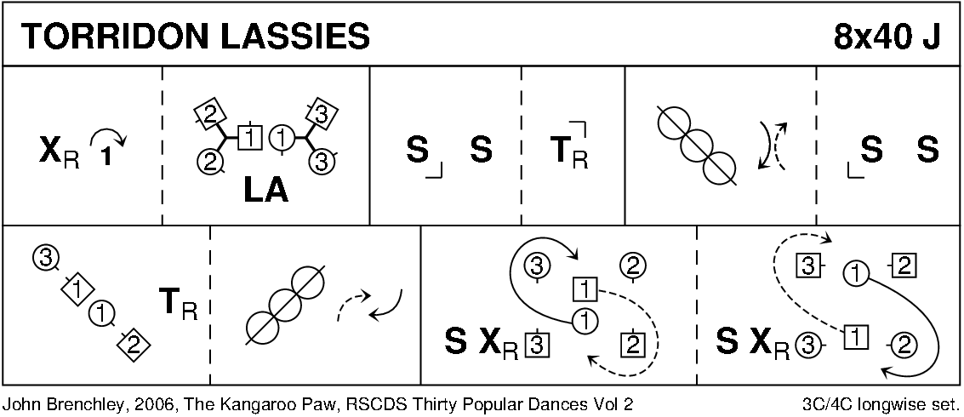

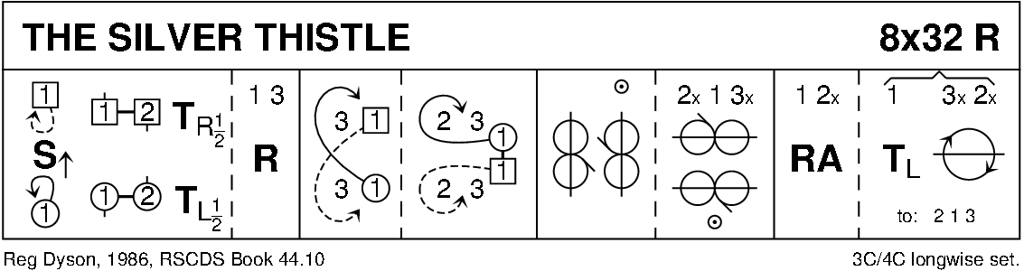
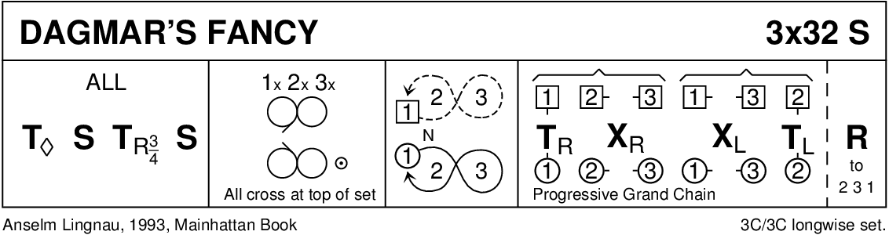

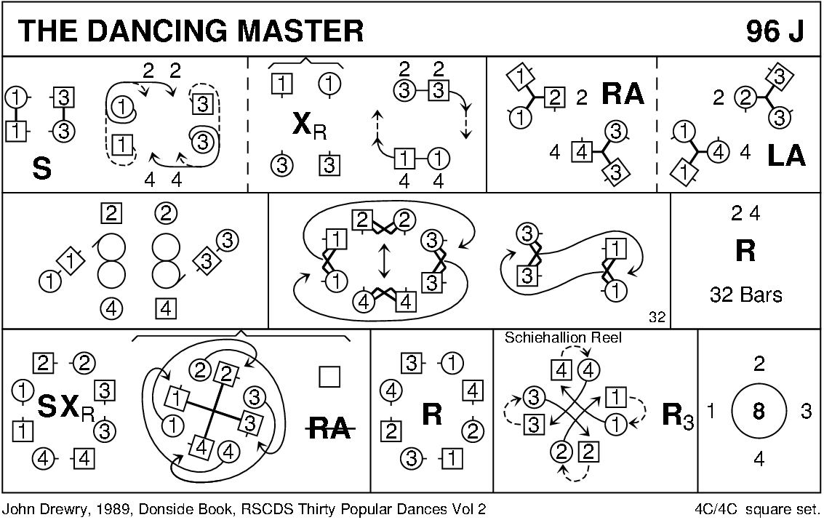

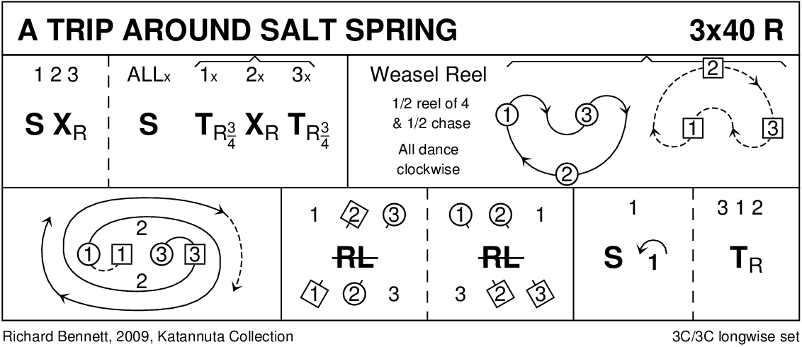

TEACHER’S CHOICE

